ANDROID CONTROLLED ROBOT

**October 29, 2019**



# Abstract

In this project of ours we are aiming to build a Robot that will be controlled using Android Phone and Bluetooth module.

The Android application includes commands that will be used to control the direction of the DC Motors. The Android application will receive the status of the robot. This project integrates the HC-05 Bluetooth Module with the 8051Microcontroller.

# Methodology

The below table shows the direction of motors and status of robot for different received characters.

|  |  |  |  |
| --- | --- | --- | --- |
| **Received Character** | **Motor 1** | **Motor 2** | **Status of the Robot** |
| F | Forward | Forward | Moves Forward |
| B | Backward | Backward | Moves Backward |
| R | Forward | Backward | Moves Right |
| L | Backward | Forward | Moves Left |
| S | Off | Off | Stopped |

# Block Diagram

To explain the clear working of this project, the following block diagram will show the different steps through which this goal is achieved.

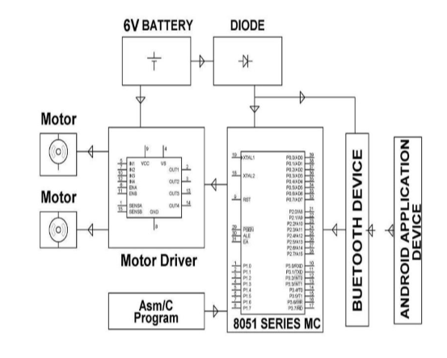

# Algorithm of the Code

* The Android device has an application which provides the user with a GUI (Graphic User Interface) to send the commands using their touch gesture. The commands are sent to the automobile through an active Bluetooth device in the form of string variables.
* The Bluetooth present in the automobile receives the string data which is then fed to the microcontroller. The microcontroller processes the data and checks for the commands of the user. On recognizing the commands (forward/backward/left/right) the microcontroller sends the information to the driver IC. Then the driver IC operates the motor to perform the desired action. This system continues with every gesture of the user to control the automobile.

# Circuit Diagram

The circuit diagram for the model & additional modification is mentioned below

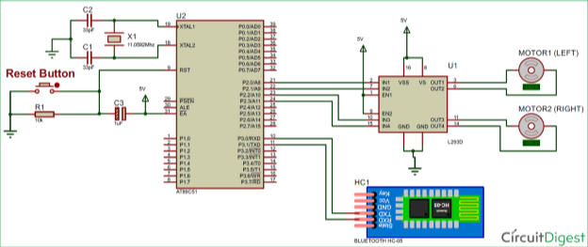

# Hardware Details

The hardware components mainly include:

1) 8051 Microcontroller

2) Android Device

3) Bluetooth Device

4) Robot Chassis

5) DC Motors and Motor Driver IC

6) Crystal

7) Voltage Regulator

8) Resistors, Capacitors

9) Battery

# Software Details

The simulation for the model will be done through the following way:

* Keil μVision5 IDE
* MC Programming Language: Embedded C

# References

• The 8051 Microcontroller and Embedded Systems: Using Assembly and C (Mazidi)

• www.circuitdigest.com

• www.elprocus.com